**Spanish B Weekly Assignments**

Agenda for April 27-May 1

Please continue to work during this quarter so that you can earn a passing grade for this course and earn your 1 credit for graduation. I will continue to collect past assignments if you would like to get those in to me. We will also continue to practice and move forward.

1. All previously assigned duolingos and duolingo podcasts are DUE at this time. Please continue to complete those. I am NOT assigning any new ones this week.
2. To complete this week’s work (which is found on TEAMS) – use the following link AND follow the directions below. Read direction FIRST before clicking on the link so that you know what you are doing! <https://www.spanish-games.net/>

#1 click start

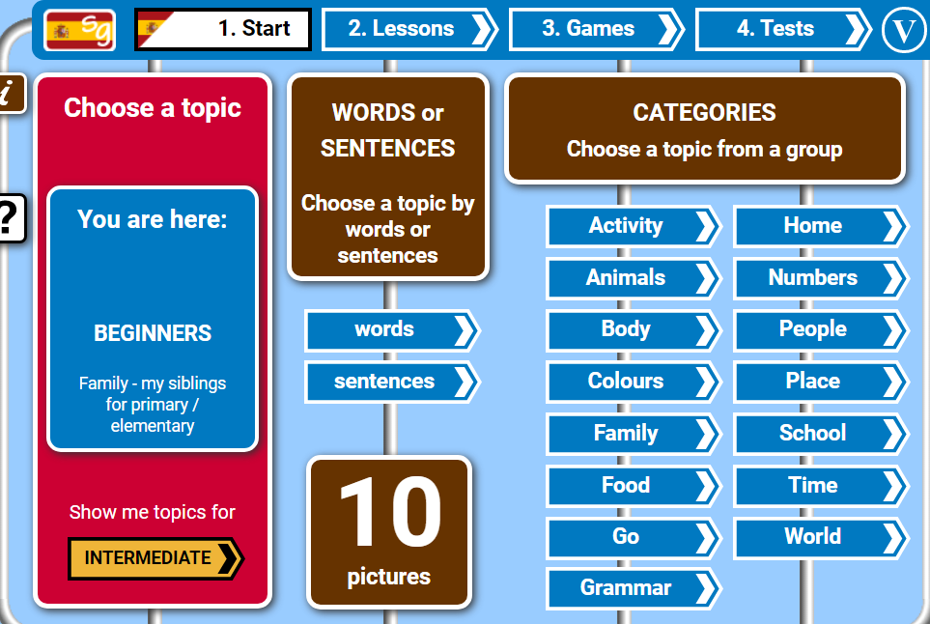

#2 click on People

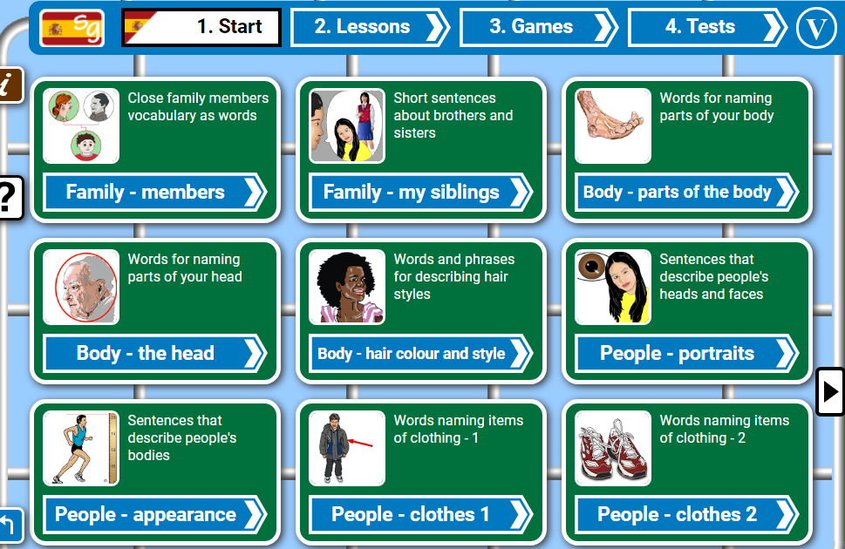

#3 click People-portraits

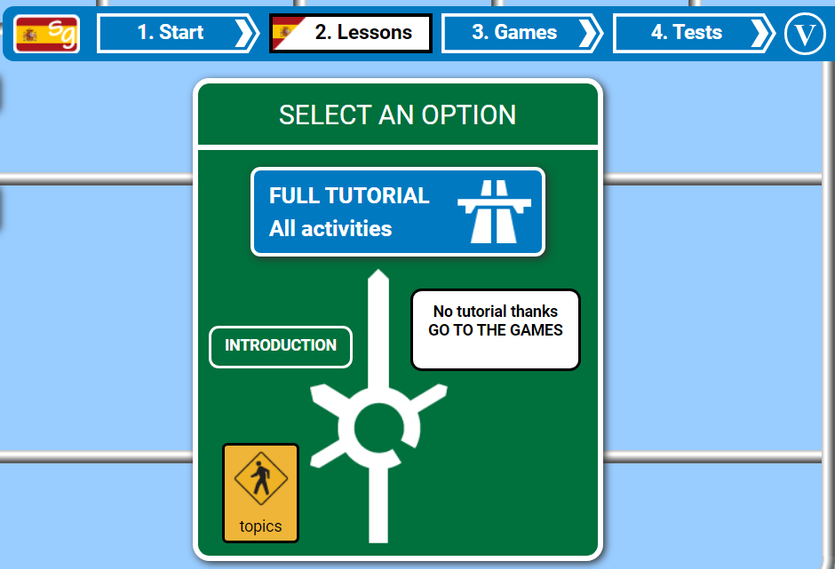

#4 Complete Full tutorial Or skip to games

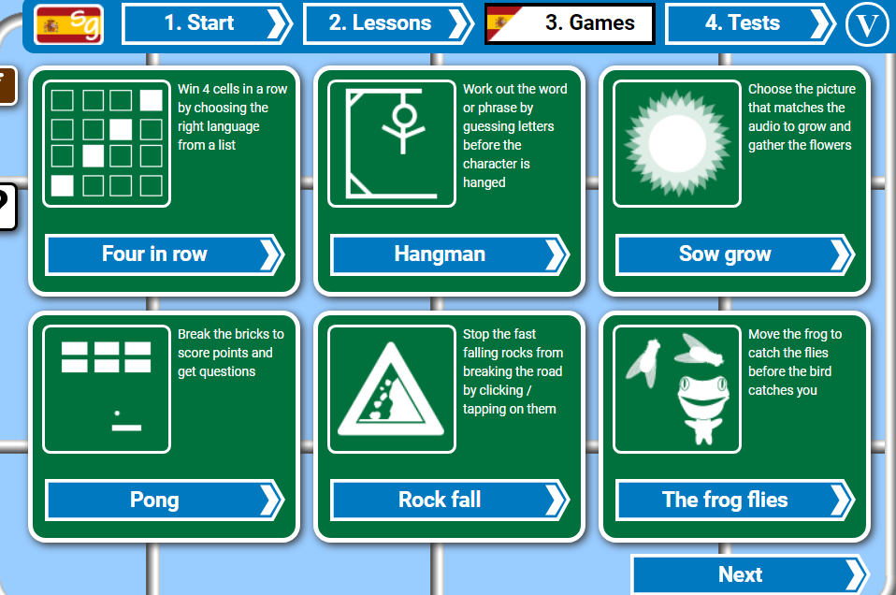

#5 Have some fun testing your knowledge by playing any or all of the following games.

t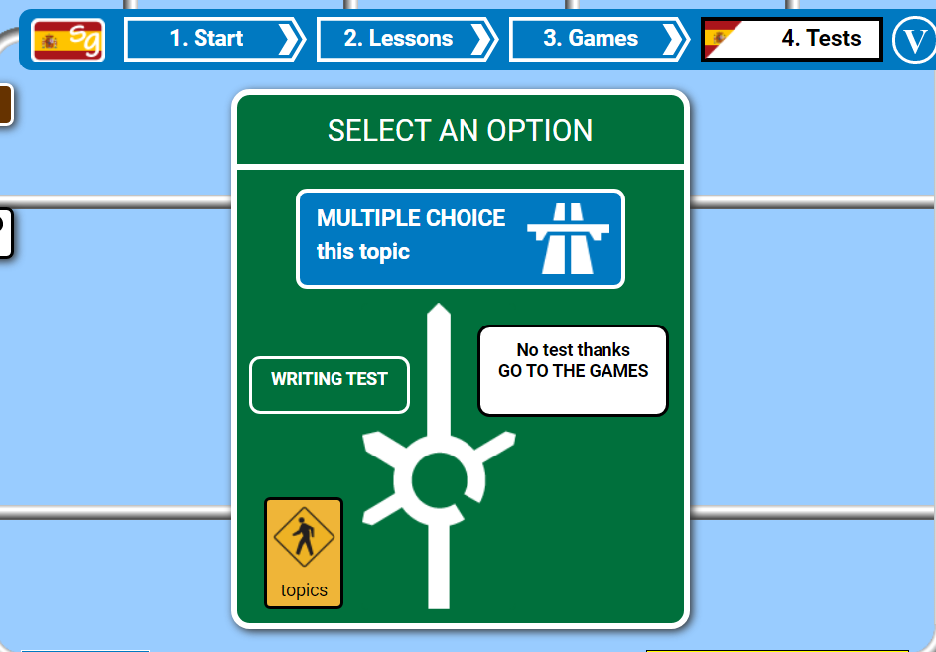

#6 Complete the test and see how well you do. You can choose either the multiple choice or Writing Test.

Once you feel that you have properly mastered this vocabulary and these concepts, GO into TEAMS to complete your graded assignment for this week ☺